# Hands-on Experiment # 4 : Worksheet

Section________1______ Date___17 Feb 2020_______________________________

No more than 3 students per one submission of this worksheet.

Student ID ________6238218321__________ Name_________Sippakorn Ornwichian____________________

Student ID _____________6238160521________ Name_________ Panupong Vijakwitchakorn________________

Student ID _________6238193221________ Name________ Wasu Sonthichai _______

## Part A: Java API

1. Place the file “Point.class” (which is a Java bytecode) in the same folder as the Java source code files you will be writing in this Hands-on Experiment.
2. Understand the source file “Point.pdf” (Point.java). Assume we want to create a point called “startPoint” at (2,3). Write the code to do the following task:
   1. Create this point
   2. Compute the distance of this point to the original point (origin)
   3. Clear this point

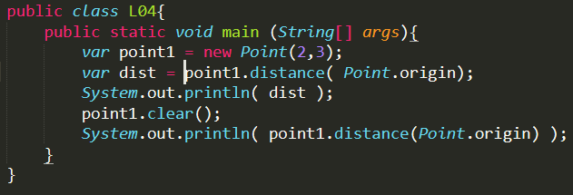

1. Explain the difference between “static data” and “object data”

Static data is the class’s data and can be used without initializing objects.

Object data is data that can be used only when objects are initialized, and they might be different in different objects.

## Part B: Scanner

1. Write a Java program “PointTest1.java” to read two points from user. Locations x and y are entered by user separately. The output is the distance between two points. (Hint: use “Scanner” to input data from user)
   1. List your source code below.

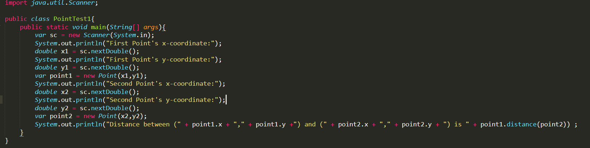

* 1. Capture the program output.

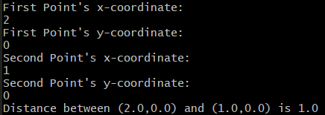

## Part C: BufferedReader (Advanced Problem)

1. Place the file “location.txt” in the same folder as the Java source code. In this file there is a single point, where x and y are shown in Line 1 and 2, respectively. Write a Java program “PointTest2.java” to read “location.txt” and output the distance to the original location (origin). (Hint: use “BufferedReader” to read data from file)
   1. What is the location in the text file “location.txt”?

(20,50)

* 1. List your source code below.

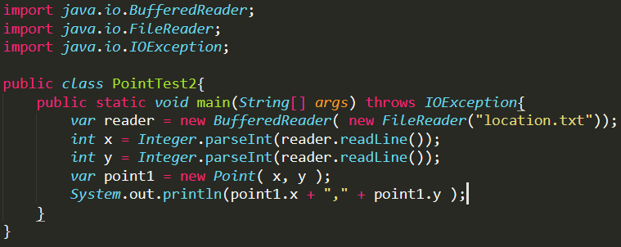

* 1. Capture the program output.

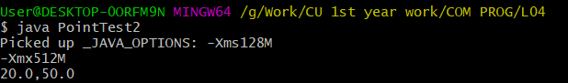

* 1. Modify location in the text file to “(2, 3)”. Then, rerun your program and capture the program output.

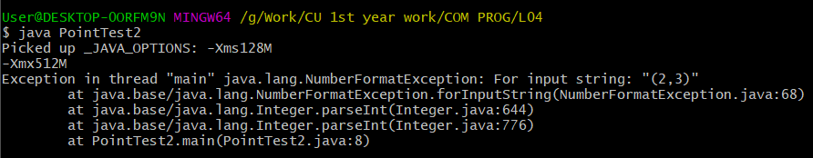

Submit this worksheet (by only one member of the group) via <http://www.myCourseVille.com> (Assignments > Hands-on Experiment # 4) **before noon of the day after your lecture.**